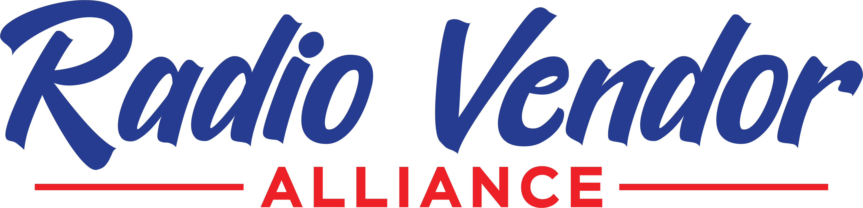

PRESS RELEASE
FOR IMMEDIATE RELEASE 3/15/24
For more information:
Tom Dobrez
708-267-4540
info@radiovendoralliance.com
radiovendoralliance.com
Navaquest Joins Radio Vendor Alliance

Navaquest, the nation’s leading digital sales trainer for small and medium size radio markets, has joined the Radio Vendor Alliance.

Upon joining the trade organization, the company’s founder, Theresa Timm acknowledge the alliance’s importance for the future of independent radio stations, “The alliance prides itself on providing the radio industry a trustworthy source for important services. To be part of an organization with some of the most respected names in the business is an honor.”

Navaquest joins the eight charter members of the RVA including RadioFX, Envisionwise, Big Deals Media, Cool Radio Streaming, Rumple, Silverback Advertising, Radio Consulting Services, and Frank Gerard Voiceovers.

“I am very familiar with Theresa’s products and impeccable reputation and feel she makes an important addition to the RVA’s offerings and scope,” said Jon Holiday, President of Radio Consulting Services and member of the RVA.

Each vendor has submitted to a review process and their inclusion in the RVA has been based on their proven track record of delivering fair market value services backed by inclusive support. As a result, RVA offers a network of trusted partners that radio operators can rely on to help them grow and succeed.

One of the internal goals of the RVA is to align our services with each other, so radio stations can succeed in today’s ever-changing marketplace. Navaquest’s training modules and digital marketing certification process can work together with a variety of existing RVA member products like Envisonwise’s webpages or Silverback’s advertising platform,” added Timm.

The RVA plans on a formal grand opening presence at the 2024 NAB Show in Las Vegas with a sponsorship of the Small and Medium Market Radio Forum (SMMRF) on the event’s opening day, Saturday April, 13. 2024.

